Eczema Ease App

Intro page

Login Page
Create a login, user id and password

Intro/questions, about you
- Gender
- Year born
- Ethnic
- Zip code

Landing Page
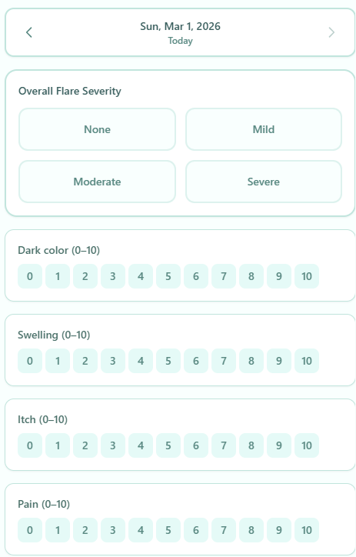
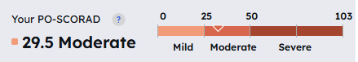
Based on these create a score, the score should be at the bottom of the 1st page
Call it Today’s Eczema Score
Score calculation: average of redness, swelling, itch and pain

skip login. into should be one-time set-up anbd should be editable. we will combine data with insights later maybe in the next version.
Change dark color to redness
Score calculation: average of redness, swelling, itch and pain

1. TODAY'S ECZEMA SCORE:
- Should the score be 0-10 (matching your symptom scales)? Yes
- Display style: Do you want a circular progress ring, horizontal bar, or number with visual indicator? Circular
2. ONE-TIME SETUP FLOW:
- Should this appear the very first time someone opens the app (before they see anything else)? yes
- Questions: Gender, Year born, Ethnicity, Zip code - any specific options for these dropdowns? Whatever is standard
BODY AREA FLOW:
- Current: Select body area, then rate symptoms separately.
- New: Should selecting a body area open a popup/modal where you rate all 4 symptoms (redness, swelling, itch, pain) for THAT specific area? Yes, but on the landing page I still want the same 4 as overall 
- Then move to next area?

2nd Page
Ask about symptom in specific body areas
For each area selected ask about the rating for each symptom

